

Ride-on Scrubber
Operation Instruction

K80+

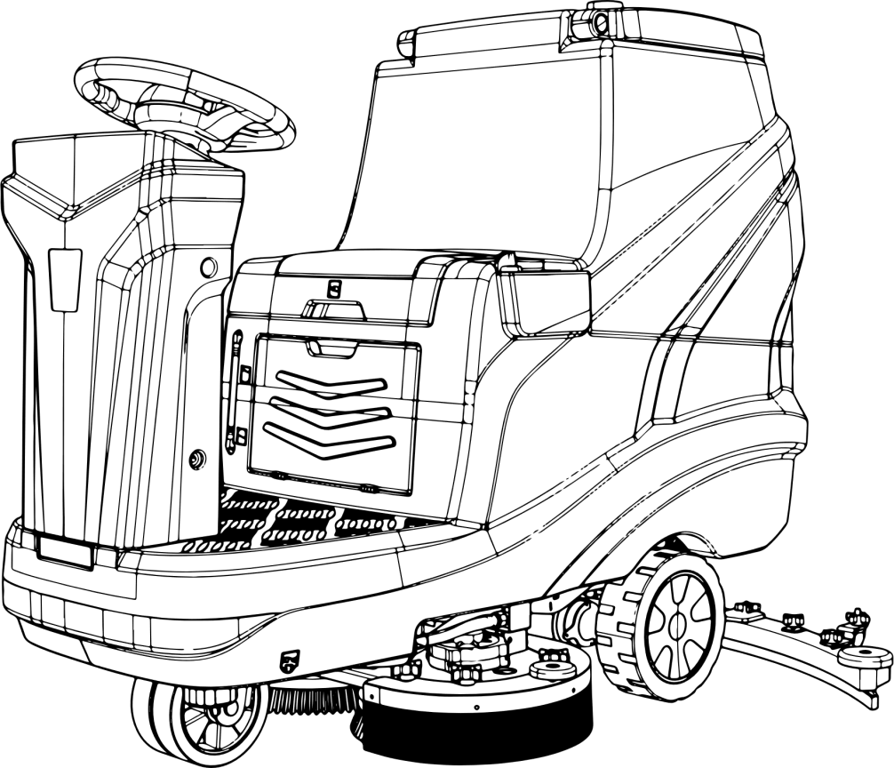

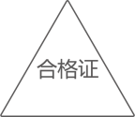

12/2023
It is strictly prohibited to use this equipment without reading this manual.

Preface
Thank you for choosing Chancee cleaning equipment. We are confident in providing you with this product which is manufactured using the latest technology and has undergone strict quality control. This manual is used to help you understand the operation and maintenance of the equipment so that you can use it more comfortably and efficiently, so please read this manual thoroughly before using.

Safety Precautions
To ensure safety, please follow the following important usage rules!
- Do not use this device while under the influence of alcohol or medication.
- Before any maintenance and repair, please turn the machine OFF, and please remove the key from the main power switch and keep it properly.
- This machine must be used by qualified and authorized personnel. Minors and disabled persons are not allowed to use it.
- Keep batteries away from sparks, flames and smoke.
5. It is prohibited to use the machine in places with dangerous, flammable or explosive gases, liquids and water vapors.
6. No loose clothing or accessories are allowed. Keep clothing, gloves and hair away from moving parts.
7. Do not smoke while the battery is charging.
8. In case of fire, please use dry powder fire extinguisher, instead of water to extinguish the fire.
9. When a machine is scrapped, accessories containing hazardous substances (such as batteries, waste oil, etc.) shall be sent to a specific center for disposal.

Safe use
- Before using the equipment, please read this user manual carefully. This will ensure that you understand the control and maintenance requirements and help you use the equipment safely.
2. If the machine is handed over to other people, please be sure to hand over the instruction manual as well and tell them to read it carefully before use.

When reading this user manual,
- This manual includes all configurations for this series of products, therefore, you may find that some of the information does not apply to your device.
- All information, specifications and illustrations in this manual are effective when this manual is published. Our company reserves the right to change specifications or designs without prior notice.
In this manual, we use the symbol with the word "Warning" to indicate the possibility of a hazard that may result in death or serious personal injury;in order to avoid or reduce the hazard, the relevant steps must be strictly followed.
In this manual, we use the symbol with the word "Caution" indicates the possibility of dangers that may cause minor or moderate personal injury or equipment damage; in order to avoid or reduce the danger, the relevant steps must be strictly followed.
( ) A mark similar to this indicates that the direction to which the arrow points is forward.
( ) An arrow similar to this indicates movement or action.

Contents
Contents 4
Chapter 1 Product Introduction 1
1.1 Applicable Scenarios 1
1.2 Equipment Overview 1
1.4 Technical parameters 2
1.6 Consumables and Optional Accessories 3
Chapter 2 Installation 3
2.1 Unloading 3
2.2 Installation 4
Chapter 3 Inspection before use 4
3.1 Check the battery 4
3.2 Check clean water level 4
3.3 Check sewage level 5
3.4 Check the wear of the brush plate 5
3.5 Check the wear of the rubber strips 5
Chapter 4 Operation instructions 5
4.1 Driving 5
4.2 Scrubbing 6
4.3 Discharging sewage 6
4.4 Shutting down 6
4.5 Charging 6
Chapter 5 Cleaning and maintenance 7
5.1 Cleaning 7
5.2 Maintenance 8
Chapter 6 Transportation and storage 9
Chapter 7 Common faults 10

Chapter 1 Product Introduction

1.1 Applicable Scenarios

This equipment can be used in a variety of scenarios, including commercial and industrial places , such as hotels, schools, hospitals, industrial offices, supermarkets, office buildings, etc.; for epoxy floors, PVC floors, terrazzo, wear-resistant floors, tiles and cement floors , wooden floors, rubber floors, different floors can be cleaned with brush plates made of different materials.

1.2 Equipment Overview

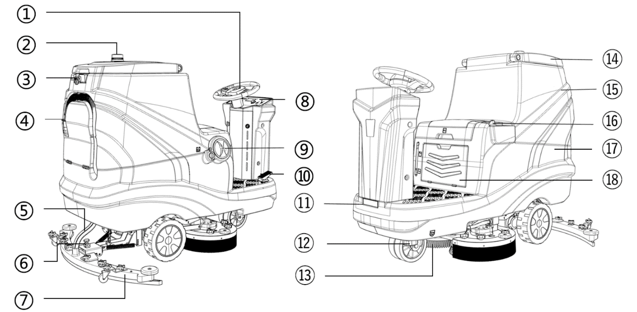

No. | Name | Function | No. | Name | Function
① | Steering wheel | Control driving direction | ⑩ | Driving pedal | Accelerate/Decelerate the machine
② | Warning Light | For warning | ⑪ | Headlight | For lighting dark environment
③ | Hook | Hang rags, brushes and other cleaning utensils | ⑫ | Water discharging port cover | Discharge clean water from the solution tank
④ | Sewage draining tube | Discharge sewage from the recovery tank | ⑬ | Brush plate | Clean the ground
⑤ | Sewage suction tube | Suck ground sewage into the tank | ⑭ | Recovery tank cover | Display the amount of sewage in the recovery tank
⑥ | Squeegee adjustment knob | Adjust the distance between rubber strips and ground | ⑮ | Recovery tank | Store recycled sewage
⑦ | Squeegee | Collect ground sewage | ⑯ | Water flow adjustment knob | Adjust the water flow of brush plate
⑧ | Control panel | Main function console | ⑰ | Solution tank | Store clean water
⑨ | Clean water adding port | For adding clean water | ⑱ | Storage room | Store charger and charging plug

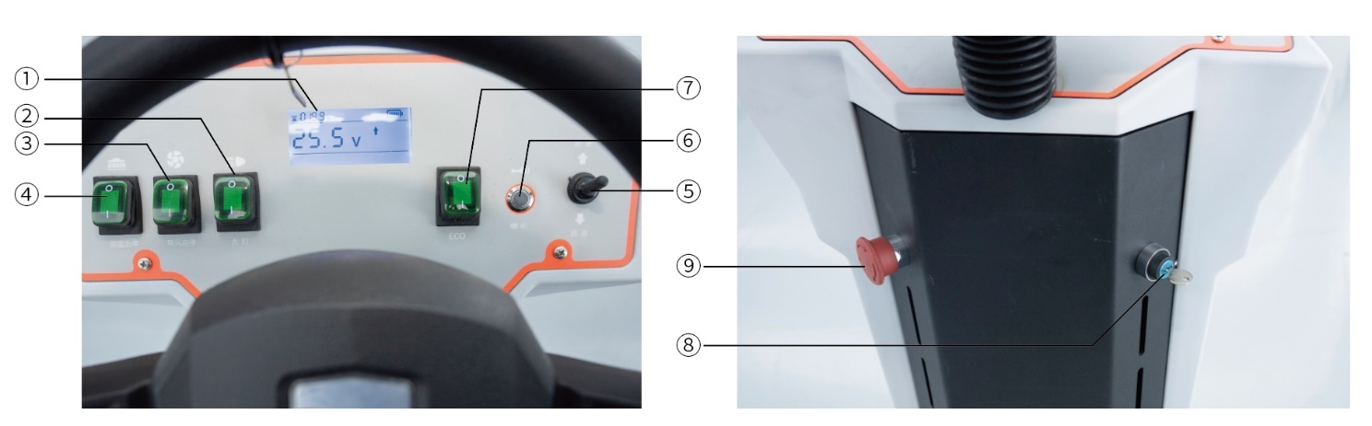
1.3 Control Panel/Buttons

No. | Name | Function
① | Voltage meter | Display the current voltage and power of the machine, also fault, machine operating status, etc.
② | Headlight | For lighting
③ | Suction start/stop | Start/stop suction motor
④ | Brush plate start/stop | Start/stop brush plate
⑤ | Forward/backward | Control the machine to move forward/ backward
⑥ | Horn | For whistling
⑦ | ECO | Energy-saving mode
⑧ | Key switch | For powering on and shutting down the machine
⑨ | Emergency stop | Shut down the entire machine in an emergency

1.4 Technical parameters
Name | Value | Name | Value
Cleaning width（mm） | 800 | Brush motor power（W） | 350*2
Squeegee width（mm） | 1200 | Driving motor power（W） | 600
Continuous running hour（h） | 3-5 | Clean water capacity（L） | 120
Theoretical working efficiency（㎡/h） | 6800 | Sewage capacity（L） | 150
Battery capacity（V/Ah） | 24/200 | Total weight（kg） | 340
Suction motor power（W） | 600 | Working size（mm） | 1600*1200*1300

1.5 Accessories list
When you open the packaging box, you will find that it contains the following components. Please check the components listed in the table. If there are anything missing, please contact us in time.
No. | Name | Quantity
① | Host | 1
② | Charger | 1
③ | Squeegee assembly | 1
④ | Tool kit | 1
⑤ | Operation instruction | 1
⑥ | Warranty card | 1

1.6 Consumables and Optional Accessories
The consumables of this equipment are listed in the table below. When any of them is worn, you need to purchase or replace it;
This equipment can cope with different scenarios through different optional accessories, which you can purchase through suppliers or manufacturers;
Consumables | Optional Accessories
Pad holder | Pad holder
Brush plate | Brush plate
Rubber strip | Cleaning pad (red)
Cleaning pad (red) | Cleaning pad (white)
Cleaning pad (white) | Lithium battery
 | Lead-acid maintenance-free battery

Chapter 2 Installation

2.1 Unloading
Caution：
Please remove the outer packaging carefully to avoid damaging the machine shell;
It is recommended to keep the packaging boxes of related products after receiving the goods, so that the machine can be repackaged later when the equipment is moved or returned or exchanged;
It is prohibited to violently unload the machine from the pallet to avoid damaging the parts;

Place the unloading wooden pallet, remove the wooden blocks that fix the big wheels, and then move the machine backwards to unload the equipment from the pallet.

2.2 Installation

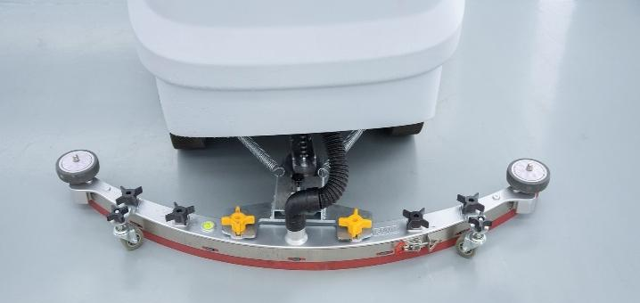
2.2.1 Squeegee installation
Step 1：Park the machine on level ground and remove the key;
Step 2：Pass the squeegee fixing screw through the tripod eyelet and tighten it with the plastic knob;
Step 3：Insert the other end of the suction tube into the suction port of the squeegee;
Step 4：Check the rubber strips and make some adjustments if necessary.

2.2.2 Connecting the battery cables
Step 1：Lift the sewage tank and check whether the wire harness on the battery is connected and tightened.
Step 2：Connect the disconnected battery poles in series. Note that the positive (+) port is red and the negative (-) port is black. After the connection is completed, put down the sewage tank.
Caution：Due to the different distances of logistics routes, in order to avoid battery loss during long journeys, the battery cables have been disconnected at the factory.

Chapter 3 Inspection before use

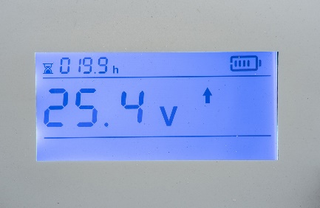
3.1 Check the battery
After turning on the power key switch, the battery meter will display the current voltage of the battery. When the voltage is about 21V, please charge it in time.
Caution：
During the use of the battery, deep discharge will cause the battery capacity to decrease and its life to be shortened. For example: the battery is often used below 21V and is not charged in time.

3.2 Check clean water level
Caution：
Please ensure that there is sufficient water, and avoid using the suction motor when there is no water. Otherwise, the motor may take in dust. In severe cases, the noise of the suction motor will become louder or the suction power will be insufficient.

3.3 Check sewage level
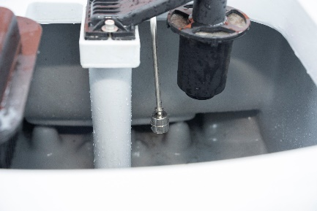
Caution：
Please pay attention to the sewage water level. When the water level reaches the float position of the water level sensor, the suction motor will stop working. Please dump the sewage in time.

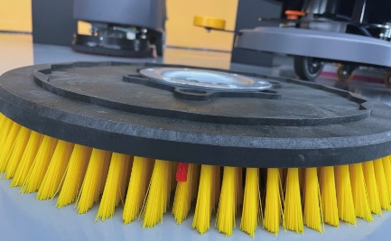
3.4 Check the wear of the brush plate
When the length of the brush plate is found to reach the red warning line, please replace the brush plate in time.

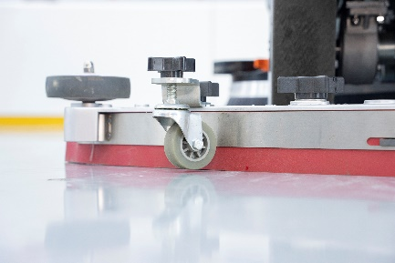

3.5 Check the wear of the rubber strips
Check whether the strips are damaged, deformed, aged or cracked. If so, please replace them in time.

Chapter 4. Operation instructions

4.1 Driving
Step 1：Turn on the main power key switch of the machine;
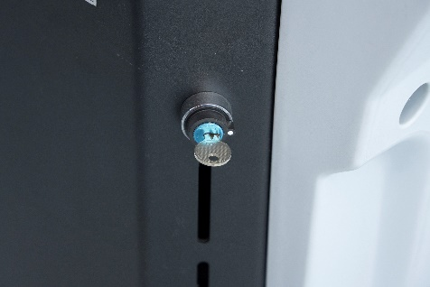
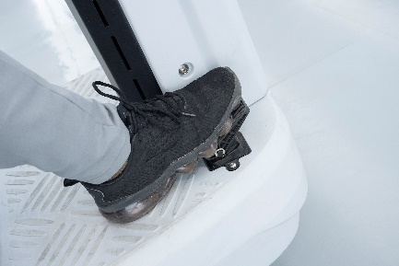
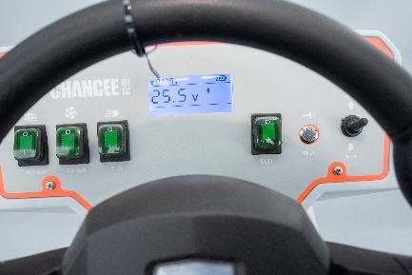
Step 2：Turn the forward/backward switch as needed, and lightly press the accelerator pedal to move the machine forward and backward.

Caution：
When the machine needs to be moved backwards or changed places, the brush plate and squeegee should be raised off the ground to avoid wear of the brush plate and deformation of the rubber strips or squeegee sheet metal parts.

4.2 Scrubbing
Step 1：Turn on the key switch of the machine;
Step 2：Press the brush plate start/stop button to lower the brush to the ground;
Step 3：Press the suction start/stop button to lower the squeegee to the ground;
Step 4：Hold the steering wheel and lightly step on the acceleration pedal to rotate the brush plate. Keep the machine running smoothly and then start cleaning (Do not drive too fast);
Step 5：Stop the brush plate and suction function after cleaning.

1
3
2
Caution：Avoid stopping the machine in the same place for a long time with the brush plate working, as this will leave unnecessary marks on the ground.

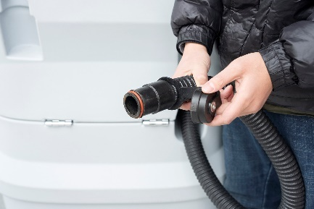
4.3 Discharging sewage
Step 1：Push the machine to a site that meets the sewage discharge standards, stop the machine, and turn off the power;
Step 2：Remove the sewage tube from the clamp at the rear of the machine, place it downwards, open the tube cover, and discharge the water. The inner wall of the tank can be appropriately rinsed with clean water.

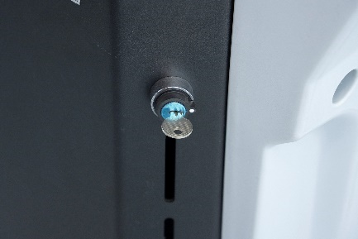
4.4 Shutting down
Step 1：Empty water in the recovery tank;
Step 2：Drive the machine to a flat ground;
Step 3：Turn off the power switch and remove the key.

4.5 Charging
The correct way to charge battery is to plug in the battery first, then the mains power; after charging, cut off the mains power first, and then the battery plug;
The power system of this floor scrubber is composed of four 6V maintenance-free lead-acid batteries connected in series, and the system voltage is 24V;
When the machine has been operating for a period of time, the battery power will drop. When the last two bars of the power meter are red, or the voltage is lower than 21V, it means that the power is insufficient and needs to be charged in time;
When maintaining the battery, please wear protective gloves to avoid contact with acidic substances of the battery;
Check whether the battery connection wire is worn and whether the contacts are loose, and replace it if necessary;
The battery terminals should be kept clean and dry, without debris and dust covering them, otherwise it will be extremely detrimental to the battery, and in serious cases, it will burn the battery;
In order to ensure that the battery has a long service life, it should be charged in time after the machine finishes working, but deep discharge is strictly prohibited;
When the machine is not used for a long time, please fully charge the battery and store the battery with the positive pole (+) disconnected.
Caution：
During use of the battery, deep discharge will cause the battery capacity to decrease and its life to be shortened. For example: the battery is often used when the voltage is below 21V and is not charged in time. If the machine will not be used for a long time (more than 15 days), it needs to be fully charged in advance, and as shown in the figure below, you should cut off the connecting wires on the battery and wrap them with insulating tape to prevent the battery from losing power due to long-term non-use.
Caution：
In addition to lead-acid maintenance-free batteries, we also have liquid-filled models and lithium-ion batteries;
For liquid-filled batteries, please check the liquid level of the battery every 20 days and replenish the electrolyte in time;
Lithium-ion batteries have a voltage protection function. When the machine voltage is lower than 21V, the power output will be automatically cut off and further use of the device is prohibited. At this time, you need to charge it in time before you can continue to use it.

Chapter 5 Cleaning and maintenance
Proper cleaning and maintenance will increase the service life of your machine, so please check and clean the machine regularly!

5.1 Cleaning
Check and clean the wheel set and remove entangled objects;
Clean the sewage tank and sewage tubes regularly, and use water to flush the dirt in the tank and blockages in the tubes;
Clean the dirt under the rubber strips regularly, and wipe the strips with a cotton rag;
Check the water filter regularly. When there are impurities in the transparent cover, rotate and unscrew the cover, and rinse it and the filter screen repeatedly with clean water.
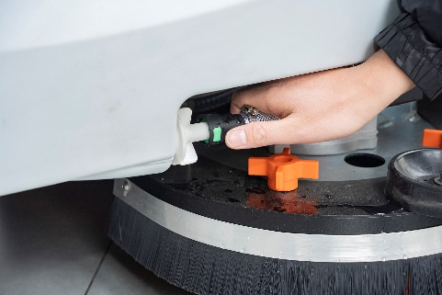
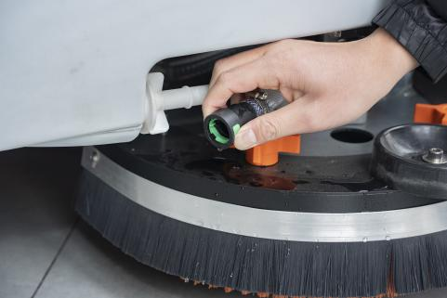
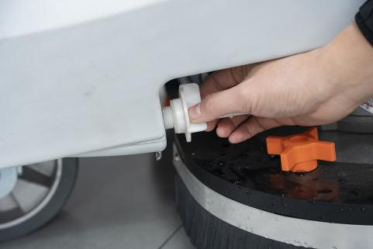
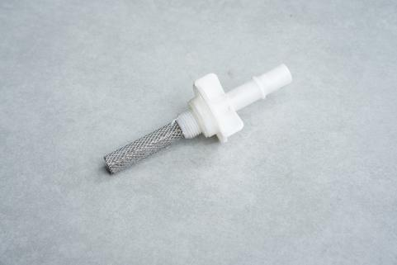
Caution：
The machine is not a tightly waterproof device. Do not flush the machine directly with water in that it may cause a short circuit in your machine or burn out the original electrical components.

Clean the filter screen (1. Press and hold the green button of the quick-plug connector and unplug the connector; 2. Unscrew the filter; 3. Clean the filter screen)

5.2 Maintenance

5.2.1 Replacement and installation of brush plate
Step 1：Park the machine on a flat ground, keep the brush plate raised, turn off the key switch, and make sure that the machine is powered off;
Step 2：Turn the plastic cross knob counterclockwise to remove the water retaining brush;
Step 3：Grab the bristles and then rotate in any direction to remove it; When installing the brush plate, make sure the flange is aligned with the button hole, and then quickly rotate it in any direction to complete the installation.
Caution：
There are two types of cleaning pads with different hardness. Choose the more suitable one according to the site.
Replacing the pad holder: The pad holder can be purchased through our company's platform. The specific replacement is to place the cleaning pad at the bottom of the pad holder and make them fit firmly;
The cleaning pad and the pad holder must fit neatly together, then install the pad holder on the machine. The steps are the same as that of the brush plate;
The cleaning pad must be soaked in clean water before using it for the first time for 10-15 minutes. A dry scouring pad will damage the floor.

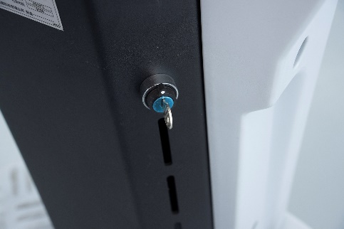
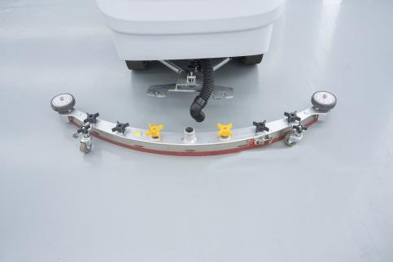
5.2.2 Replacement and installation of rubber strips
Turn off the power
Remove the squeegee
Step 1：Park the machine on a flat ground,, turn off the key switch, and make sure that the machine is powered off;

Step 2：unscrew the plastic knobs counterclockwise to remove the squeegee assembly;

Removing of rubber strips
Step 1：Unscrew the orange knob of the squeegee and remove the universal wheel;
Step 2：Pull up the lever of the rubber strip pressure plate and remove the plate;
Step 3：Remove the bottom plate of the squeegee assembly, and remove the front and rear rubber strips of the squeegee;
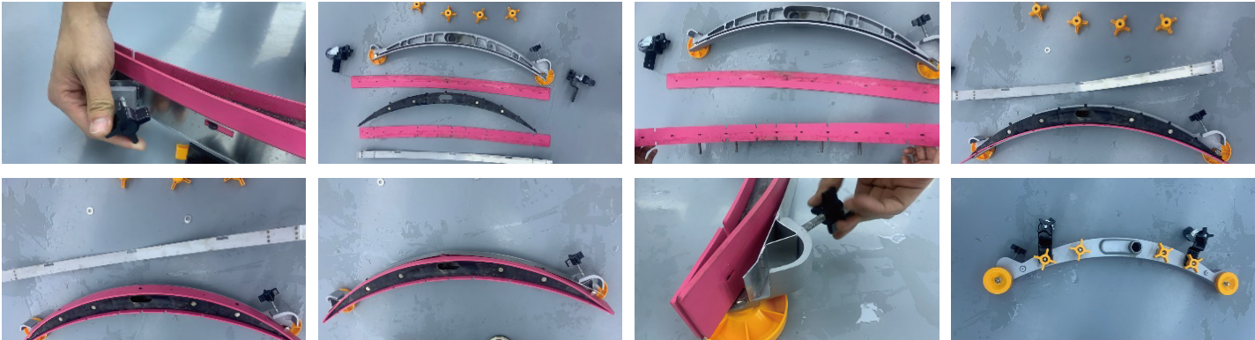

Installation of rubber strips
Step 1：Align the holes of the front rubber strip with the protrusions of the plastic component of the squeegee;
Step 2： Fix the plastic component on the bottom plate of the squeegee and the two black nuts;
Step 3：Align the holes of the rear rubber strip with the protrusions of the plastic component of the squeegee;
Step 4：Install the rubber strip pressure plate and lock the buckle;
Step 5：Install the squeegee universal wheel.

5.2.3 Squeegee adjustment
Step 1：Place the squeegee flat on the ground, adjust the height of the universal wheel so that it is 3-5mm higher than the bottom of the rubber strips, and both sides are the same height;
Step 2：Install the squeegee on the machine, press the suction start/stop button. After the squeegee is put down, turn off the power, and observe whether the squeegee is parallel to the ground;
Step 3：If the squeegee is not parallel to the ground, turn the squeegee adjustment knob on the tail swing to make it parallel to the ground and to make the squeegee strips in complete contact with the ground;
Step 4：If you find that the squeegee is tilted during the floor cleaning, adjust it according to the above method.
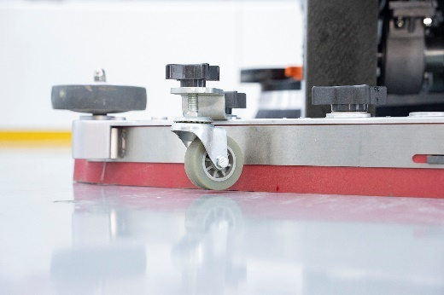
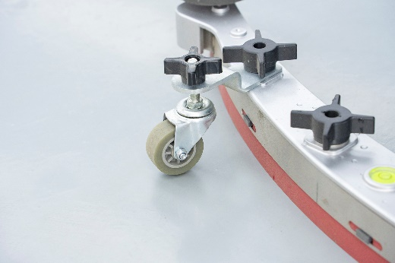

Chapter 6 Transportation and Storage
6.1 Transportation
If the machine and the accessories need to be lifted, it is recommended that you put them on a pallet and lift them with a forklift. And water in both tanks must be emptied when transporting the machine;
In order to prevent slipping and damage caused by collisions during transportation, please ensure that the binding should be firm and the center of gravity should be stable to ensure safety. For transportation vehicles whose surfaces are in contact with the machine, both surfaces should be packed with soft pads or hard cardboard;
Lightly load and unload. Do not let the machine fall, roll, be pressed, etc. or turned upside down.

6.2 Storage
Before storing the machine, clean the machine, see [Chapter 5, 5.1 Cleaning] for details;
For machines that will not be used for a long time, anti-rust treatment should be done before storage. Check the easily corroded parts, and apply butter;
If the machine will not be used within 7 days, store the machine fully charged in a clean, dry and away from flammable places;
If the device is not used for a long time, fully charge the device battery, then disconnect the battery connector, and store the battery at room temperature above 0 degrees. It is required to charge it once a month;
In areas with lower temperatures, clean water and sewage need to be emptied to prevent the water tank from cracking due to water freezing.

Chapter 7 Common faults
Fault | Phenomenon/Part | Troubleshooting | Solution
Charging failure | Charger failure | If the charger is not connected to the machine, see whether the green light will be on. If the machine is plugged in, the red light is on, and the built-in fan of the charger does not run | Replace the charger
Charging failure | Charging interface oxidation | Whether there is any obvious oxidation trace on the copper interface | Clean the charging interface oxide
Suction motor not working | Switch | Turn on the switch and check if the switch light is on | Replace the switch
Suction motor not working | Connector | Check whether the connector is tightly inserted or has fallen off | Tighten the connector
Suction motor not working | Controller | Check whether the controller screws and terminals are tight | Contact customer service center
Suction motor not working | Suction motor | Use a multimeter to measure whether there is voltage at the input end of the suction motor | Contact customer service center
Brush motor not working | Switch | Turn on the switch and check if the switch light is on | Replace the switch
Brush motor not working | Connector | Check whether the connector is tightly inserted or has fallen off | Tighten the connector
Brush motor not working | Controller | Check whether the controller screws and terminals are tight | Contact customer service center
Brush motor not working | Brush motor | Use a multimeter to measure whether there is voltage at the input end of the brush motor | Contact customer service center
Water not coming out | Clean water tube | Whether there is any scale in the transparent tube of the clean water tube | Clean clean water tube
Water not coming out | Filter | Whether there is dirt on the filter | Clean filter
Water not coming out | Solenoid valve | Measure whether the solenoid valve has input voltage | Check the input voltage of the solenoid valve. If it is normal, remove it and clean the blocked part. Replace the solenoid valve if necessary.
Loud noise | Resonance of rubber strips and sewage suction port | 1. Is there any abnormal sound when the rubber strips are lifted? 2. Is there any obvious vibration in the water absorbing tube? | Adjust the height of the squeegee mecanum wheels
Loud noise | Suction motor | 1. Is there any abnormal sound when the rubber strips are lifted? 2. Is there still any abnormal sound after the water absorbing tube is pulled out? | Replace the suction motor
Brush plate | Frequent drop | Has the brush plate been lowered to the ground before turning on the switch? | This behavior is an incorrect operation and may easily cause the brush plate buckle to wear. Replace the buckle when necessary.
Brush plate | Buckle wear | See the brush plate buckle for wear | Replace the brush plate buckle
The machine not sucking water properly | Floating ball cage clogged | Check the floating balls in the cage | Need extra attention in daily use
The machine not sucking water properly | Tube blocked | Clean the water suction tube | Need daily cleaning and maintenance
The machine not sucking water properly | Recovery tank sealing circle | Sealing circle aging | Replace accessories
The machine not sucking water properly | Squeegee | 1. Whether the strips are cracked, aged or deformed 2. Whether the strips are wavy | 1. Adjust the angle of the squeegee and the height of the universal wheel of the squeegee; 2. Replace the rubber strips
Machine not walking | Solenoid brake | Check the solenoid brake gear when the machine is turned off to see if it is not the downward gear | Contact customer service center
Machine not walking | Accelerator pedal | 1. Shortly connect the accelerator pedal connector plug. If the machine can move, there is something wrong with the accelerator pedal. 2. The fault light flashes 7 times. | Contact customer service center
Machine not walking | Controller | Use a multimeter to measure whether there is input voltage to the controller | Contact customer service center
Machine not walking | Driving axle | Use a multimeter to measure whether there is input voltage to the driving axle | Contact customer service center

